AnySzn Business Plan.

Executive Summary

Mission Statement & Vision

Mission Statement
At AnySzn, I believe that fashion should empower, not overwhelm. My mission is to revolutionize the way people discover, shop, and express themselves through fashion by combining cutting-edge AI technology with curated, community-driven experiences. I want to make fashion personal, effortless, and inclusive—giving every user the tools to feel confident, stylish, and authentically themselves.
Through a seamless blend of personalization, ethical innovation, and social connection, AnySzn provides not just a marketplace—but a movement—where individuality meets convenience, and inspiration turns instantly into action.

Vision Statement
I envision a world where fashion is frictionless: where users don’t just scroll for inspiration, but can shop entire outfits instantly, try them on virtually, and express their unique identity through a truly connected platform.
My goal is to become the leading global fashion marketplace for Shopify brands, empowering emerging designers, influencers, resellers, and consumers alike. Through immersive tech like AI outfit matching, virtual try-ons, smart mirrors, and VR shopping, AnySzn will reshape online fashion retail into a sustainable, smart, and community-driven experience.

Problem Statement: Fashion Inspiration Is Easy - Shopping It Should Be Too
Fashion is more visual and accessible than ever—yet turning outfit inspiration into reality is still broken. I created AnySzn because consumers, creators, and brands are stuck in a system that wasn’t designed for how we shop today.

The Current Fashion Experience is Fragmented
- Time-consuming outfit decisions: On average, women spend 17 minutes/day, and men 13 minutes/day, deciding what to wear. That’s over 100 hours a year—just choosing an outfit.
- No direct path from inspiration to checkout: Shoppers see looks on Instagram, TikTok, or Pinterest—but can’t find or buy those outfits easily. Pinterest, for example, is a go-to for outfit inspiration, but the journey ends at the pin. Users save aesthetic looks without any ability to shop the full fit, get personalized styling, or match ideas to what’s already in their wardrobe. It takes multiple tabs, endless searching, and manual guesswork to recreate even one outfit. Pinterest inspires—but it doesn’t activate. AnySzn bridges that gap by turning scrolls into shopping. You don’t just save the look—you wear it, buy it, or even sell your own.
- Zero personalization: Most platforms don’t learn your style, know what you own, or suggest pieces that actually make sense for you.
- Influencers can't monetize directly: Fashion creators have huge followings (some with 400K+), but lack a platform where fans can buy the outfits they post—and they earn nothing from the inspiration they generate.

Visual Proof of Market Demand
Visual Demand is Massive—But Shopping Still Fails
The appetite for fashion inspiration is explosive. A single search for “outfit inspiration” on Instagram yields millions of posts and videos, many with hundreds of thousands to millions of views. Below is a screenshot captured on Instagram’s Explore page—proving the sheer volume of user interest:

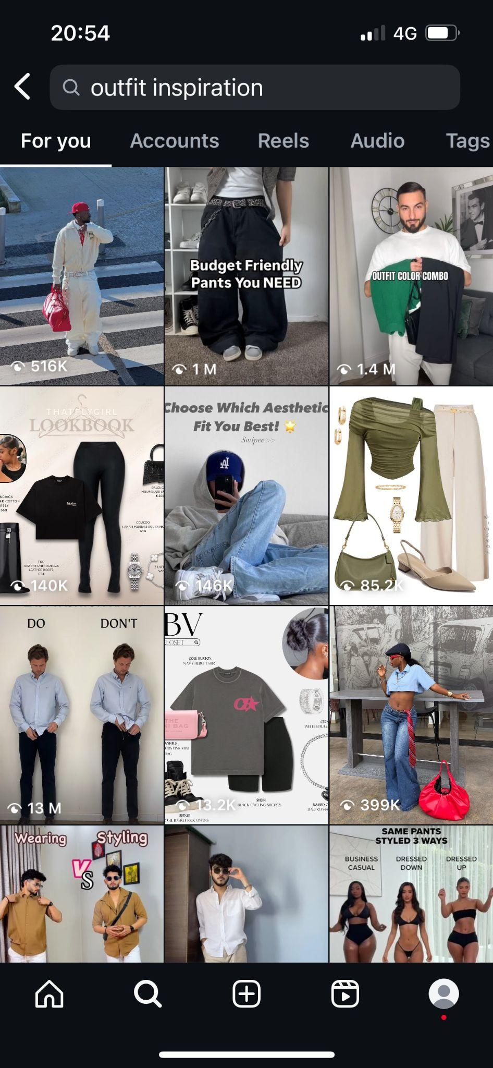
This isn’t hypothetical traffic. It’s real-world, real-time data—millions of users actively searching, saving, and engaging with outfit content. But here’s the catch: there’s no seamless way to act on that inspiration. You can’t tap and shop. You can’t recreate the full outfit. Users are left guessing what to buy—and where.
Meanwhile, creators and stylists like NON OUTFITS (667K followers) post beautiful, curated outfit collages daily. They generate high engagement and loyal followers—but zero direct revenue from those looks. Their fans admire, save, and comment “Where can I buy this?”—but the shopping journey stops there.
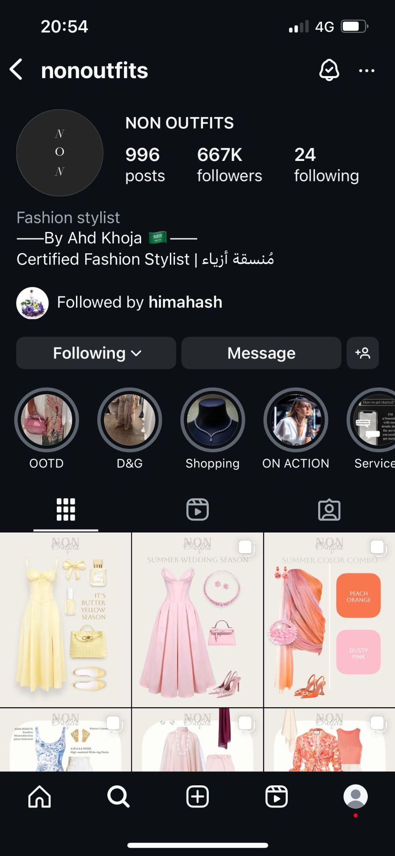
These visuals prove two critical truths:
- Demand for outfit inspo is real, constant, and global.
- Monetization and shopping functionality are still missing.
AnySzn doesn’t just recognize this gap—we solve it.
By turning static inspiration into shoppable outfits, enabling creators to earn, and empowering users to instantly buy full looks, we bridge the gap between discovery and purchase. This isn’t just visual validation. It’s undeniable market proof.

Who This Hits Hard
Florencia (32), Fashion Influencer – 415K followers
She inspires thousands with her style, but has no way to monetize full outfits. Her followers constantly comment “Where’s the link?”—but the tools don’t exist.
Jake (22), Uni Student on a Budget
Loves fashion, but doesn’t know where to start. He finds one shirt he likes, but not the rest of the look. “I want the whole fit. Not just a t-shirt.”

How AnySzn Innovates the Multi-Brand Marketplace Model
Successful companies like Harvey Nichols, Selfridges, Farfetch, ASOS, Zalando, and others have built marketplaces that centralize diverse fashion brands. AnySzn follows this model—but with game-changing twists:
1.Exclusive Shopify Brand Integration
Unlike traditional marketplaces like Farfetch or ASOS that partner with established retail brands, AnySzn exclusively aggregates fashion brands built on Shopify. We empower both emerging and established independent designers, unlocking a massive and growing segment of the online fashion industry.
2. Unlocking the Shopify Goldmine
There are over 500,000 Shopify fashion brands, many of which struggle to gain exposure. AnySzn gives them a centralized, curated platform to reach style-conscious consumers—at scale.
3. Unified Shopping Journey Across Brands
- AnySzn offers users a seamless experience—mix and match pieces from different brands, build personalized outfits, and checkout instantly in one transaction. No more switching tabs, juggling carts, or losing interest.
- They can compare prices side-by-side—budget-friendly or premium.
- They experience a unified shopping journey that other platforms can’t offer.
4. Meeting What Modern Consumers Actually Want
The success of marketplaces like Farfetch ($2.3B revenue), ASOS (£2.85B revenue), and Zalando (€10.5B revenue) proves that users prefer centralized, multi-brand platforms.
AnySzn builds on this preference with added layers of AI, personalization, VR try-ons, and Shopify-first exclusivity.
5. Personalized by AI, Powered by Community
Users scan their wardrobe, get custom outfit suggestions, and shop pieces that actually suit their style, body, and budget.
6. Creator Commerce Comes to Fashion
Influencers and resellers can list full fits, earn commissions, and finally turn fashion inspiration into revenue.

The Opportunity
- The UK spent £66.2 billion on clothing in 2023[Statista, 2024].
- 50% of women and 41% of men in the UK shop online for fashion monthly[YouGov/Drapers, 2023].
- Global e-commerce will hit $6.4 trillion by 2029, with fashion being a major driver[Shopify, 2023].
- Online preference: 37% of consumers prefer shopping fashion online[McKinsey & Company, 2023].
The industry is booming—but no platform connects Shopify brands, AI-driven personalization, and influencer monetization like I’m doing with AnySzn.

In Summary
The future of fashion isn’t just e-commerce—it’s connected commerce.
AnySzn solves a deeply felt problem at scale: it connects creators, simplifies the user journey, and brings personalization to a market that desperately needs it.
I’m not just building a fashion platform—I’m fixing the shopping experience, one outfit at a time.

The Solution: Introducing AnySzn.
AnySzn is the first AI-powered fashion platform built exclusively for Shopify-based fashion brands. It merges outfit inspiration, intelligent tech, and seamless shopping into one experience—solving the fragmented, outdated fashion journey users face today.

Core Features Solving Real Problems
Curated Multi-Brand Marketplace
- A centralized platform where users can shop from hundreds of Shopify fashion brands.
- Buy complete outfits or individual pieces—all in one platform, one cart, one seamless experience.
- Users can compare luxury and budget-friendly versions of each item side-by-side.
- Perfect for discovering emerging brands and new trends without endless searching.
AI-Powered Outfit Matching
- Scan any clothing item (photo or real-life) to find complementary outfit suggestions.
- Personalized AI learns user preferences, body type, and shopping habits.
- Suggests outfits that fit your style, occasion, and climate.
- Future updates will include AI predictions for new styles and mood-based outfit planning.
Outfit Creation: Mix, Match & Preview
- Users can build their own custom outfits using a real-time visual builder.
- Swap items to create different versions of the same look.
- Save favorite outfits and come back to purchase later.
E-Commerce & Price Intelligence
- Real-time price comparison engine ensures users get the best deal across brands.
- Instant order placement through direct integration with Shopify stores.
- Automated confirmation and tracking, just like leading e-commerce platforms.
Ready-Made & Seasonal Outfits
- Professionally styled, ready-to-shop outfits released by season (Spring/Summer, Fall/Winter).
- Perfect for users who want instant style without doing the work.
- Option to customize or swap individual items before purchase.
Community & Social Integration
- Influencers, resellers, and stylists can list and sell complete outfits for commission.
- Users can follow, like, and comment—turning fashion shopping into a social experience.
- Integration with Instagram and Hinge to showcase your style across platforms.
- “Fit of the Week” and “Fit of the Year” competitions to gamify engagement.
Ethical & Sustainable Shopping
- Filters for ethical brands, recycled materials, and eco-conscious clothing.
- Future roadmap includes a clothing recycling program to promote circular fashion.

Phase 1 (MVP): Initial Product Release
This MVP focuses on core functionality, designed to address the biggest user pain points and provide instant value from launch:
User-Friendly Interface
- Clean and intuitive design for smooth navigation
- Basic onboarding to understand user style and preferences
Create Your Own Outfit
- Mix and match tops (T-shirts, hoodies, jackets, etc.) with bottoms (shorts, trousers, skirts, etc.)
- Real-time visual preview of full outfits
- One-tap purchasing for the entire outfit
- Save outfits for future reference or seasonal planning
Ready-Made Outfits
- Curated by fashion experts based on seasonal trends
- Complete outfit bundles, ready to buy
- Flexible editing of individual pieces in each outfit
E-Commerce Functionality
- Seamless Shopify brand integration for direct orders
- Instant order confirmation system ensures a professional checkout experience
Marketplace for Individual Clothing Pieces
- Centralized multi-brand platform built around Shopify’s ecosystem
- Users can explore and purchase individual fashion items across multiple brands
- Supports both curated shoppers and those searching for specific products
Budget and Fit Filters
- Filter by budget range, season, and occasion
- Helps users quickly find what fits their wardrobe, their needs, and their wallet

Long-Term Vision (Backed by Roadmap)
From AI stylists to VR storefronts, AnySzn will evolve into a fully immersive fashion universe. Future plans include:
- Advanced AI for mood-based and event-based outfit planning
- Social commerce integration with TikTok, IG, and dating apps
- Resale platform and wardrobe scanning
- Smart mirrors + full VR shopping experiences

In Summary
AnySzn is a one-stop fashion ecosystem:
- For users: it solves what to wear and where to buy it.
- For creators: it unlocks monetization and audience reach.
- For brands (especially on Shopify): it creates a modern, high-conversion distribution channel.
This isn’t just fashion tech. It’s the future of how people shop, dress, and express themselves—backed by smart systems and style-first thinking.

Product Roadmap & Development Phases
I’ve structured development into agile, achievable phases. The goal is to launch fast, validate demand, and scale based on clear traction. This roadmap reflects a realistic balance of product ambition and technical execution—aligned with current technology readiness and growth stage milestones.

Phase 1: MVP Launch – Core Shopping Platform
Timeline: June 2026 – March 2027 (9 Months)
Goal: Launch a lean but complete product that solves key user problems and validates market fit.
Core Features:
- Clean, user-friendly interface and onboarding
- Create Your Own Outfit: real-time outfit builder + save feature
- Ready-Made Outfits curated by stylists (editable by user)
- Shopify brand integration for real-time purchases
- Budget and seasonal filters
- Marketplace for individual pieces
- Influencer-led outfit collections
These are low-to-medium complexity features and can be executed with a small dev team or via contract-based builds using Shopify’s API ecosystem.

Phase 2: Smart Discovery, Ethical Fashion & Basic Social Tools
Timeline: April 2027 – March 2028 (12 Months)
Goal: Layer in personalization, creator monetization, and community building.
Feature Additions:
- AI outfit recommendations based on purchase history and preference data
- Social features: likes, comments, follows, user profiles
- "Fit of the Week/Year" competitions
- Ethical & eco-conscious filters
- Expanded Shopify catalog and emerging brand onboarding
- Influencer affiliate links for monetized curation
- Light TikTok/Instagram integration (share outfits, track link clicks)
These features require user data + initial traction, so Phase 1 completion is key for successful Phase 2 rollout.

Phase 3: Creator Economy, Resale & Advanced Personalization
Timeline: April 2028 – June 2029 (15 Months)
Goal: Deepen monetization tools and community retention via resale and smart wardrobe features.
Feature Additions:
- Reseller Marketplace: users list and sell their own looks
- Reseller reviews, trust score system
- Wardrobe Scanner (Beta): scan your clothes to get missing outfit suggestions
- Split Screen Shopping: compare luxury vs. budget fits visually
- Collaborative influencer drops
- Dating profile outfit links (Instagram/Hinge)
These require image recognition + wardrobe AI logic, which will be built on data + engagement from earlier phases.

Phase 4: Immersive Tech & Circular Fashion Infrastructure
Timeline: July 2029 – December 2031 (2.5 Years)
Goal: Introduce advanced features like resale authentication, AR try-ons, and prepare for immersive commerce.
Feature Additions:
- AR mobile try-ons (basic): view items on body using smartphone
- Sustainability initiatives: user-driven recycling program
- Expanded resale + vintage section
- “Shop My Closet” integration using wardrobe scan + purchase history
- Live-streamed fashion events with in-app purchasing
- Pre-build smart mirror SDK (R&D begins mid-2030)
These are high-complexity but now realistic with user traction, tech maturity, and team expansion.

Phase 5: Future of Fashion – Smart Mirror, VR & AI Stylists
Timeline: 2032 – 2035
Goal: Lead the immersive fashion revolution through full virtual try-ons, AI stylists, and metaverse retail.
Feature Additions:
- Smart Mirror (Physical Hardware Rollout)
- VR shopping via Meta, Apple Vision, or headset platforms
- Fully autonomous AI stylist — recommends outfits for occasion, weather, mood
- Virtual outfits + NFT fashion drops
- Global metaverse fashion shows with live purchasing
These are R&D-intensive features. They will be funded and developed in partnership with tech companies, once AnySzn has proven scale and secured strategic capital.

Roadmap Summary

Phase | Timeline | Focus
1 | Jun 2026 - Mar 2027 | MVP, Core Shopping, Shopify Integration
2 | Apr 2027 - Mar 2028 | AI Lite, Ethical Filters, Social Discovery.
3 | Apr 2028 - Jun 2029 | Creators Tools, Resale, Wardrobe Scan
4 | Jul 2029 - Dec 2031 | AR Try-On, Circular Fashion, Smart Mirror R&D
5 | 2032 - 2035 | VR Commerce, AI Stylist, Fashion Metaverse
In Summary
This product roadmap reflects a realistic, staged approach to building a fashion tech company from the ground up. I’ve designed each phase to deliver clear value, unlock new revenue streams, and prepare for long-term innovation. By focusing on traction first and technology later, I’m building a fashion future that’s practical, personal, and powerful.

Market Opportunity

Market Size: TAM, SAM, SOM
Market | Definition | Size
TAM (Total Addressable Market) | Global online fashion retail market | $1.5 Trillion by 2027 [Statista, 2024]
SAM (Serviceable Available Market) | Fashion e-commerce platforms with AI & multi-brand focus | $400 Billion+ [McKinsey FashionScope, 2023
SOM (Serviceable Obtainable Market) | Gen Z/Millennial UK/US/Canada spend on online fashion via curated platforms | ~£3.2 Billion annually [Deloitte Digital Spending Report, 2024]

Why This Matters:
Online shopping is booming. In the UK alone, 60% of all fashion purchases will be online by 2026, up from 35% in 2019 [Statista, 2023]. Globally, e-commerce is forecasted to hit $6.4 trillion by 2029, with fashion leading the charge [Shopify Future of Commerce Report, 2023].

Industry Trends in Fashion Tech & Online Shopping

Trend | Relevance to AnySzn
AI & Personalization | 80% of shoppers are more likely to purchase from brands offering personalized experiences [Epsilon, 2021]. AnySzn uses AI to build that experience around every user.
Social Commerce Boom | TikTok Shop, Instagram Shopping, and influencer links are reshaping buying behavior. Yet there’s no central platform where users can shop full outfits instantly.
Sustainability Focus | 65% of Gen Z consider sustainability when choosing fashion brands [First Insight, 2023]. Our eco-fit filters + resale plan directly serve this market.
Rise of Resale | The secondhand apparel market is forecasted to reach $350B by 2028 [ThredUp Resale Report, 2023].
Immersive Commerce | AR try-ons and VR stores are projected to be used by 35% of global shoppers by 2027 [Accenture, 2022]. We’re already building toward that future.

Key Insight:
Fashion isn't just visual—it's tech-powered. AnySzn’s AI + social + resale model matches every major consumer trend of this decade.

Target Audience

Segment | Profile
Gen Z (18–25) | Social-first shoppers who value style, sustainability, and tech-driven experiences
Millennials (26–40) | Efficient buyers with high online spend—value convenience, style, and personalization
Influencers & Resellers | Creators with 50K–500K+ followings who want to monetize curated looks
Emerging Shopify Brands | 500K+ brands [Shopify, 2023] looking for exposure, conversions, and community integration

Visuals & Charts
1. Global Fashion E-Commerce Growth (2022–2029)
Source: [Statista Digital Commerce Outlook, 2024]
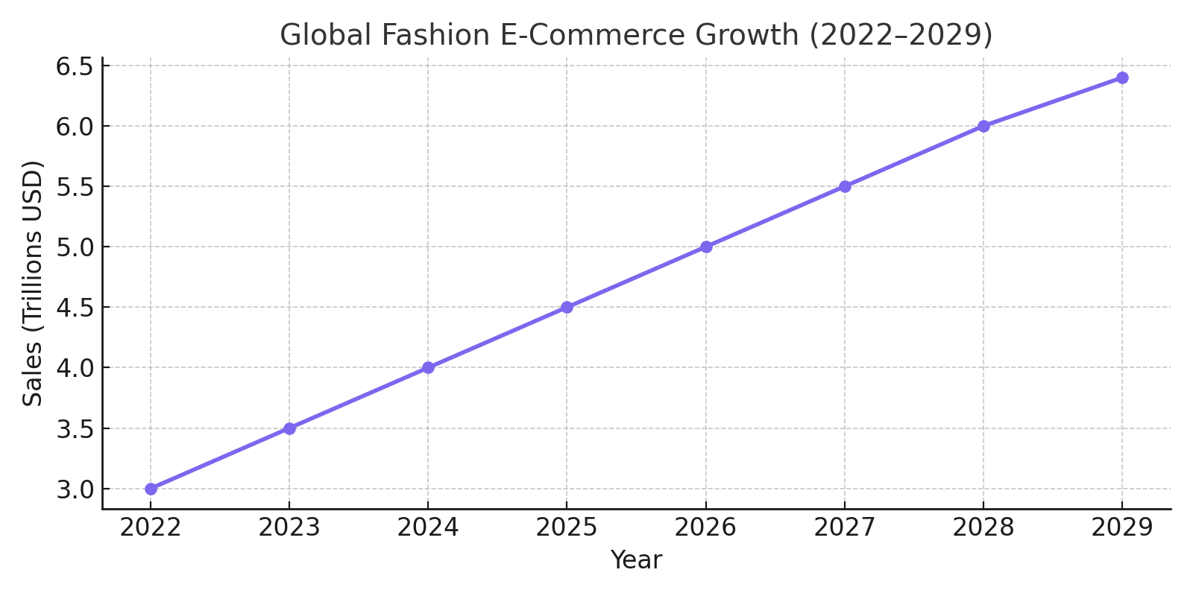
2. UK Online Fashion Spend – Past vs Future
Source: [Office for National Statistics UK, 2023]; [Statista Forecast, 2024]
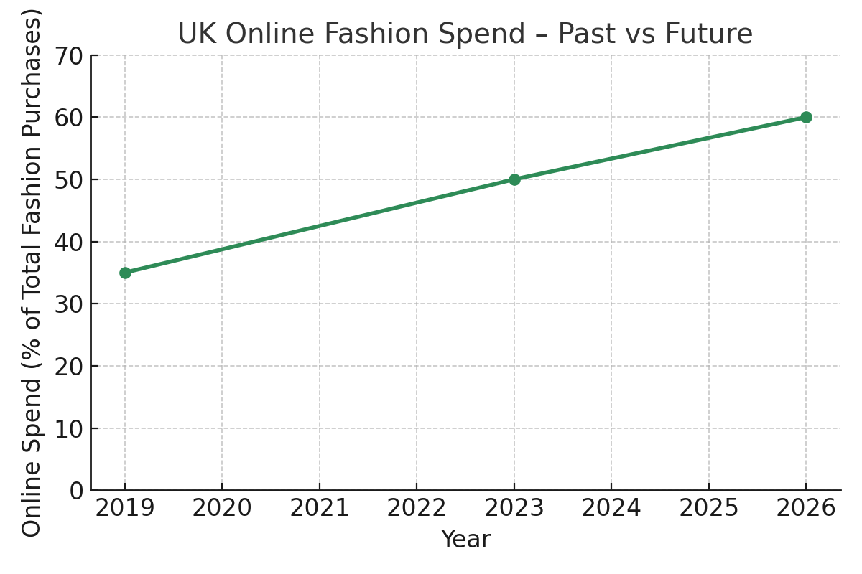
Why Now?
- AI is changing commerce. Consumers want tailored, not generic. AnySzn delivers fit, price, and style—auto-magically.
- Inspiration → Action. People don’t want to just “like” outfits—they want to wear them. We bridge that final click.
- Shopify is fashion’s new playground. But discovery is broken. AnySzn brings 500K brands into one platform, one tap.

Competitive Edge

Feature | AnySzn | Competitors (ASOS, Farfetch, StyleDNA)
Shopify-Exclusive Integration | Yes | No
AI-Driven Personalization | Advanced | Limited
Virtual Try-On & Smart Mirror | Roadmap-Ready | Basic or None
Social + Resale Marketplace | Built-In | Mostly Absent
Sustainability & Ethical Filters | Core Feature | Optional

Conclusion
The market is massive, and the timing is perfect.
With AI, social commerce, and the rise of Shopify brands converging, AnySzn is the right product, for the right market, at the right time.
And with the support of Shopify as a strategic partner or investor, we’re ready to scale the future of fashion.

Competitive Analysis

Summary Table: How AnySzn Stands Out

Comparison of Niche & Direct Competitors in Fashion-Tech

Feature | AnySzn | Birdsnest | Outfittery | Dresoo | StyleDNA | Stylebook
AI-Powered Recommendations | Yes, Advanced + Outfit Matching | Basic | Basic | Basic | Good | None
Ready-Made Outfits | Yes, Curated, Editable, Shoppable | Yes | None | Yes | None | None
Virtual Try-On & VR | Yes, AR + VR Roadmap-Ready | None | None | None | None | None
Wardrobe Scanner | Yes (AI - powered) | None | None | None | Yes | Yes
Community & Social Commerce | Yes, Integrated with IG/TikTok, Community | None | None | None | None | None
Price Comparison & Budgeting | Yes, Split view: luxury vs. budget | None | None | None | None | None
Shopify-Exclusive Integration | Yes, First of its kind | None | None | None | None | None
Sustainability Focus | Yes, Core offering | Yes | None | None | None | None
Reseller Marketplace | Yes, Integrated with ratings & reviews | None | None | None | None | None
Geographic Scope | Yes, UK to start, then Global | AU only | Europe | Unclear | Unclear | Unclear
Demographic Reach | Yes, All genders + inclusive fits | Women only | All | Unclear | Mixed | Mixed

Comparison with Large-Scale Fashion Marketplaces

Feature | AnySzn | ASOS | Zalando | Farfetch | SSENSE | Lyst
AI-Powered Recommendations | Yes, Advanced + Outfit Matching | Basic filters only | Personal style profiles | Minimal, trend-based | None | None
Ready-Made Outfits | Yes, Curated, Editable, Shoppable | Yes | Limited | Yes, Curated Designer Lokks | Yes, Curated | Varies
Virtual Try-On & VR | Yes, AR + VR Roadmap-Ready | Basic/AR (limited) | None | None | None | None
Wardrobe Scanner | Yes(AI -powered) | None | None | None | None | None
Community & Social Commerce | Yes, Integrated with IG/TikTok, Community | None | Influencer edits | None | None | None
Price Comparison & Budgeting | Yes, Split view: luxury vs. budget | None | None | None | None | Yes, Core Function
Sustainability Focus | Yes, Core offering | Yes, Eco-edit filters | Yes, Sustainability Badge | None | None | None
Reseller Marketplace | Yes, Integrated with ratings & reviews | Creator storefronts via Collabs | None | None | None | None
Geographic Scope | Yes, UK to start, then Global | Global | Europe | Global | Global | Global
Demographic Reach | Yes, All genders + inclusive fits | Mainly Gen Z/Millennials | Broad | Premium buyers | Luxury + Streetwear | Broad

Why AnySzn Wins
While most fashion platforms focus on just one feature (closet tracking, outfit suggestions, or e-commerce), AnySzn unifies them all—and builds on them with the first fully integrated platform for Shopify-based brands.
AnySzn is not trying to compete by doing the same things better—it's winning by:
- Creating an entire fashion ecosystem—not just an platform.
- Offering AI-powered personalization with a live wardrobe scanner and mood-based outfit matching.
- Enabling creators and resellers to sell looks, not just post inspiration.
- Making fashion instant, visual, and frictionless—from Instagram scroll to in-cart.
- Being the only platform with Shopify-first integration, unlocking over 500,000 fashion brands into one global marketplace.
Traditional fashion giants like ASOS and Farfetch dominate through scale, but lack innovation. Their platforms offer inventory—not ecosystems. None of them connect visual discovery, AI styling, outfit creation, and resale in one unified experience. AnySzn doesn't just compete—we redefine the category.
Unlike Lyst or Zalando, we go beyond search and filters. Unlike Farfetch or SSENSE, we democratize fashion commerce through creator-led, price-conscious, and inclusive tools. And unlike fast-fashion retailers, we’re building for longevity, not just transaction volume.
No one—big or small—is delivering this full-stack ecosystem the way AnySzn does. And with Shopify-first integration, we're activating an entirely untapped supply network: 500,000+ fashion brands waiting for discovery.
For a more detailed breakdown of each competitor's strengths, weaknesses, and strategic gaps, please see the Appendix: Full Competitor Summaries.

Marketing and Go-To-Market Strategy:
AnySzn is entering the market with a strong focus on digital-first, community-driven strategies designed to reach Gen Z and Millennial consumers through social, experiential, and performance-based channels.

1. Go-To-Market Strategy (Launch Phase: Months 1–3)
Target Market: Gen Z and Millennial consumers, ages 18–30, in the UK who are fashion-forward, socially conscious, and engage with trends via TikTok, Instagram, and pop culture.
Launch Channels & Activities:
- Social Media Advertising (Meta, TikTok): Launch paid ads targeting interest-based audiences with initial product visuals and brand story.
- Influencer Seeding: Collaborate with 5–10 micro-influencers (10K–100K followers) for unboxing and styling content.
- Email Pre-Launch Campaign: Launch “early access” signup campaign using pop-ups and social CTA.
- Launch Party (One-off): Host an exclusive brand launch event, inviting the first 25 early supporters and influencers to create buzz and content.
- PR & Press Outreach: Distribute press kits to fashion blogs and Gen Z lifestyle platforms.

KPI Goals by End of Month 3:
- 5,000 Instagram followers
- 1,000 TikTok followers
- 1,000 email subscribers
- £5,000 in online revenue
- At least 2 media features

2. Ongoing Marketing Strategy (Post-Launch: Month 4+)
Social Media Marketing
- Organic posting 5x weekly on TikTok & Instagram.
- Trend-jacking relevant content formats.

Influencer Marketing
- Monthly partnerships with 2–4 influencers.
- Mix of gifted and paid collaborations.
- Reposting UGC (user-generated content) for social proof.

Email Marketing
- Weekly newsletters.
- Automated flows: abandoned cart, welcome series, post-purchase.

SEO and Content Creation
- Bi-weekly blog posts (style guides, sustainability topics).
- On-page SEO optimisation for product pages.

Affiliate Program
- Launch affiliate platform (e.g. Refersion).
- Recruit 10–15 affiliates in first quarter.

Community Engagement
- Branded merchandise giveaways.
- Involve community in co-creation through polls, surveys, and feedback loops.

PR & Digital Press
- Maintain contact with press leads.
- Quarterly press releases on new collections or campaigns.

Analytics & Optimisation
- Use Google Analytics, Meta Pixel, and Hotjar for CRO.
- Monthly A/B testing on email subject lines, ad creatives, and CTA buttons.

Customer Retention Strategy
- Introduce referral discounts and post-purchase loyalty incentives.
- Launch “Refer a Friend” program offering discount codes for both parties.
- Quarterly thank-you gifts or exclusive content for repeat customers.

Quarterly Review & Optimisation
- Every three months, review marketing metrics against KPIs.
- Use data insights to reallocate underperforming budgets or scale high-performing channels.
- Adjust creative direction and messaging based on trends and performance feedback.

Revenue Model
AnySzn is designed with a multi-dimensional revenue model to ensure sustainable early-stage profitability, long-term scalability, and diversified income streams. Our strategy balances transactional, subscription, advertising, service-based, and product-based monetization methods.
Platform Purchases: The Platform generates revenue through a £0.99 service charge applied when users buys an outfit or an individual piece of clothing.
- Timing: This charge will be implemented from launch, making it the primary revenue stream in Year 1.
Future Phases:
1. Subscription Model (Premium Memberships)
- Premium Features: Offer users access to premium features via a monthly or annual subscription, including:
  - Early access to exclusive drops
  - Advanced AI outfit recommendations (mood-based, event-based)
  - Additional virtual try-on capabilities
  - Detailed fashion insights and seasonal trend forecasting. Recurring subscription revenue will create predictable cash flows and increase customer lifetime value (CLV).
2. Advertising and Brand Sponsorships
- Sponsored Content: Partner with brands to feature sponsored fits, exclusive capsule collections, and promoted placements within the platform.
- In-Platform Advertising: Integrate non-intrusive, highly targeted ads tailored to user interests and fashion preferences, ensuring relevance without diminishing user experience. This channel generates high-margin, scalable advertising revenue.
3. Reseller Platform Monetization
- Listing Fees: Charge resellers a fee to list curated fits and outfits for sale.
- Transaction Fees: Collect a percentage of every successful resale transaction.
- Premium Exposure Options: Offer upgraded visibility for top-performing resellers. By tapping into the booming resale economy, we capture transaction volume from both primary and secondary fashion markets.
4. Virtual Styling Services
- Personal Styling Packages: Offer users access to professional human stylists for personalized outfit curation.
- AI-Powered Styling Recommendations: Charge micro-fees for advanced AI wardrobe scans, mood-based outfit planning, and custom outfit generation based on user data. These services enhance customer loyalty while unlocking a high-value, high-margin upsell channel.
5. Virtual Reality Shopping and Smart Mirror Hardware
- VR Headset Software Licensing: Sell or license our VR-powered virtual shopping experiences to users and retail partners.
- Interactive Smart Mirror Sales: Sell branded smart mirrors for personal and retail use, providing immersive try-on experiences at home or in-store. These emerging technology products open up premium B2B and B2C revenue opportunities, especially as immersive commerce adoption grows.
6. Data Monetization
- Consumer Insights Reports: Sell anonymized fashion trend, shopping behavior, and consumer preference data to fashion brands and retailers.
- Market Research Services: Provide detailed trend analyses, seasonal forecasts, and consumer behavior studies based on platform-generated data. Strict data privacy standards and anonymization protocols will ensure compliance while unlocking valuable new revenue streams.
7. Own Clothing Line (Vertical Integration Strategy)
- Launching AnySzn-Branded Clothing: After achieving critical mass of users and brand trust, we will introduce our own fashion line, featured prominently in:
  - AI outfit recommendations
  - Curated ready-to-wear collections
  - Exclusive seasonal drops
Brand Strategy: Build loyalty by blending owned apparel with emerging brands, maximizing margins while reinforcing platform exclusivity. The clothing line will be strategically timed to launch post-market adoption to capitalize on built-in demand and maximize profitability.

